BLOOGING PLATFORM FOR EXAMINATION DATABASE

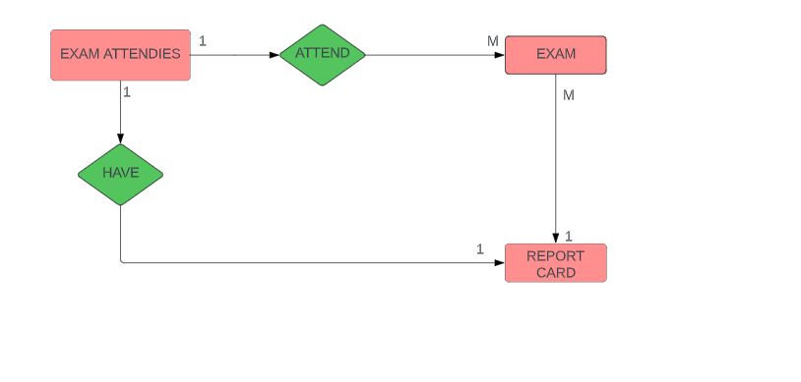

TABLE:EXAM ATTENDIES

{

STUDENT NO:VARCHAR,

NAME:CHAR,

PHONE NO:INT,

EMAIL:EMAIL,

}

TABLE:EXAM

{

SUJECT CODE:VARCHAR,

SUBJECT:CHAR,

}

TABLE:REPORT CARD(WEAK ENTITY)

{

SUBJECT CODE:VARCHAR,

SUBJECT:CHAR;

NAME:CHAR;

SCORE:INT

GRADE:CHAR,

}